Find objects in your house that begin with each letter of the alphabet.  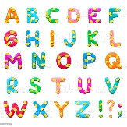 | 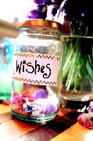  Make an ‘ideas’ or ‘wishes’ jar- fill an empty jar or bottle with slips of paper showing your wishes. |   Create a song or some music. | 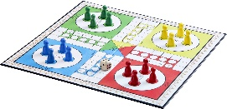  Play a board game. | 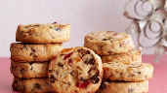  Bake something that includes fruit.
Build a den.  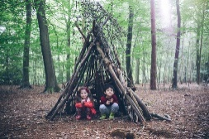 | Make a jigsaw by cutting up a photo or picture from a magazine. 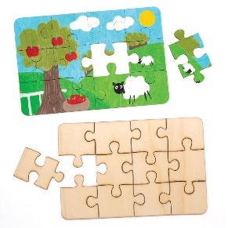 | 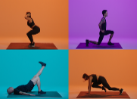  Keeping Active  Work out an exercise routine for someone else to follow. | Write a note/ postcard/letter to a neighbour.  | Write/draw about something you could do to show each of the school SPARKS.  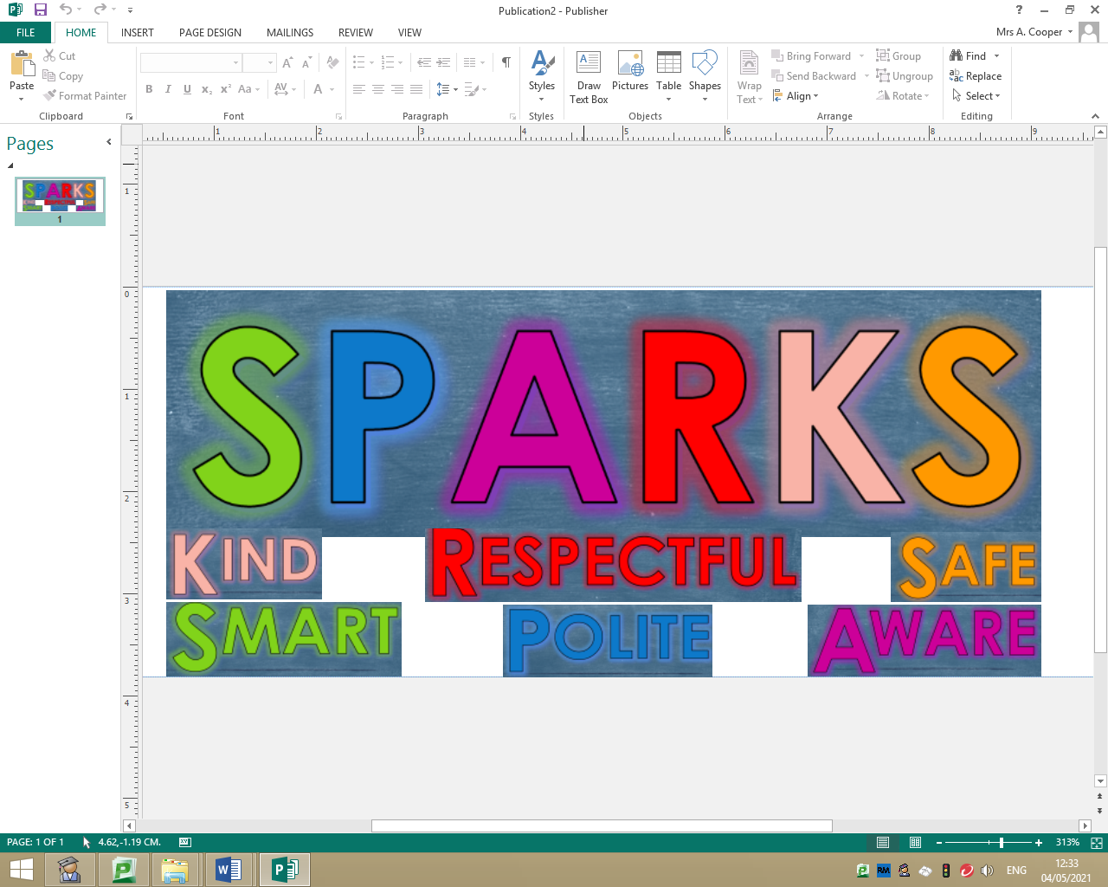
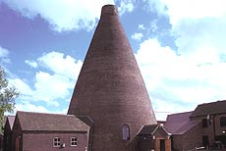  Visit the building from your Local Area Study. Take a photo of you outside it, or draw a picture. | 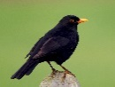  Count how many different kinds of birds you see in 15mins- try and name some of them. | 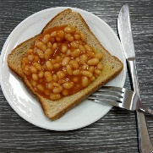  Make a ‘Master Chef’ meal out of ‘beans on toast’! |   Create some exercises your friends could do when you go on the mile track. | 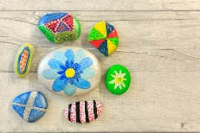  Paint/ decorate a pebble and give it to someone as a gift.

Name____________________________________________ Class _____________________
Please complete as many of the activities above, as you can. We would love to see photos (or other ‘evidence’ of your work) but don’t worry if that’s not possible. Put a tick next to each activity you manage to complete and bring this sheet back into school on Friday.

